JUNIT TESTING-------  
Exercise – 1 Setting Up Junit

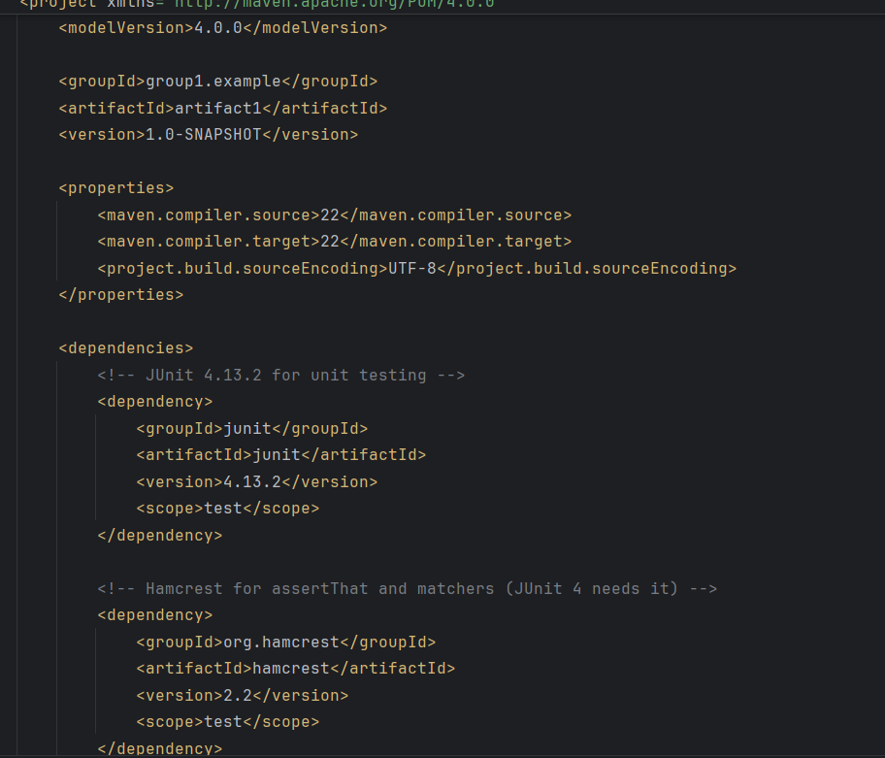

Exercise – 3 Assertions in Junit

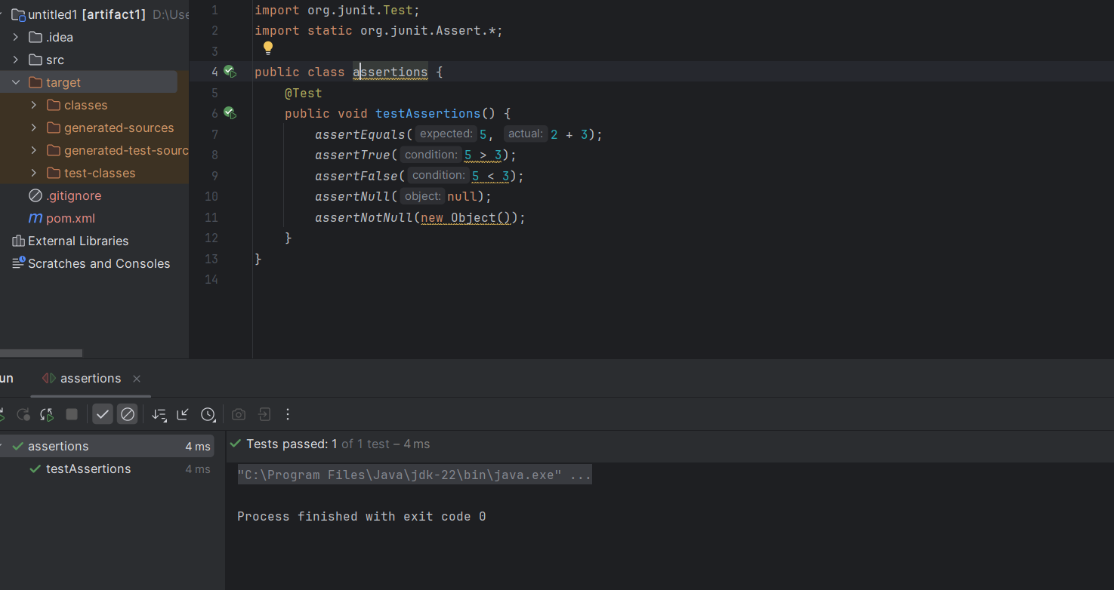

Exercise 4: Arrange-Act-Assert (AAA) Pattern, Test Fixtures, Setup and

